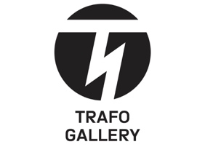
Turns the body into an image of the soul.
Trafo Gallery presents a monographic
exhibition by Siegfried Herz
titled The Great Noon.
Prague, July 24, 2026 – Trafo Gallery will present a monographic exhibition by painter and photographer Siegfried Herz titled The Great Noon starting September 11. Curated by Otto M. Urban, the exhibition project foregrounds themes of mental exposure, vulnerability, and existential solitude. In the unrelenting light of "high noon," Herz's paintings strip away human protective masks and transform the body into a pure reflection of the soul.
The grand opening will take place on Thursday, September 10, at 7:00 PM, during which an accompanying catalog designed by Jana Vahalíková will also be introduced to the public for the first time. A guided tour with the exhibition's curator will take place on Wednesday, October 7, at 6:00 PM.
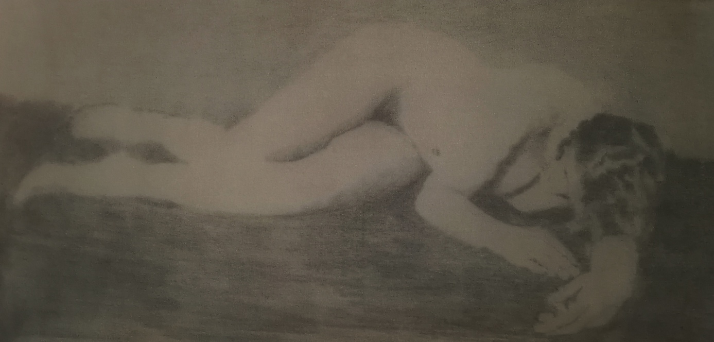
The paintings, drawings, and photographs of Siegfried Herz (b. 1986) come across as a revelation from a forgotten era—from the restless boundary between Symbolism, Expressionism, decadent melancholy, and a private diary. Yet their timelessness is not an escape into the past, but the result of a deep inner isolation from which the artist’s work emerges. The exhibition The Great Noon explores the moment of uncovering and exposure. Nudity in Herz’s approach is neither an erotic motif nor an aesthetic nude, but a metaphor for a state in which a person loses the ability to protect themselves.
"Midday is usually associated with light and the peak of the day. In Herz's concept, however, it is not idyllic. It is harsh, unforgiving, almost painful. It is a moment when shadowy refuges disappear and man is exposed to the light with no possibility of escape. Yet the more light falls on Herz’s figures, the more clearly their mystery emerges," explains the exhibition's curator, Otto M. Urban.
The material nature of the works themselves also plays an important role in Herz’s practice. Stains, dripping pigment, bleeding colors, and disturbed surfaces create the impression that the painted surface itself has undergone a process of injury. The image thus opens up without surrendering, and exposure in Herz's work is always linked to preserving mystery.
The artist himself, Siegfried Herz, comments on the philosophical and existential roots of the exhibition:
"Day and its midday are the hour of supreme affirmation. That is when shadows are shortest and everything that wished to hide is forced out into the light. Modern man has grown accustomed to viewing nudity through erotism or morality. Nudity, however, is an argument neither for pleasure nor virtue. It is a state of existence. I do not offer you memories of physical unity, but the embodiment of moments in which man approaches his highest potential—unconcealment."
On the occasion of the opening, Trafo Gallery is publishing a representative accompanying catalog designed by Jana Vahalíková. The catalog will be available for purchase for the first time directly during the opening reception on September 10.
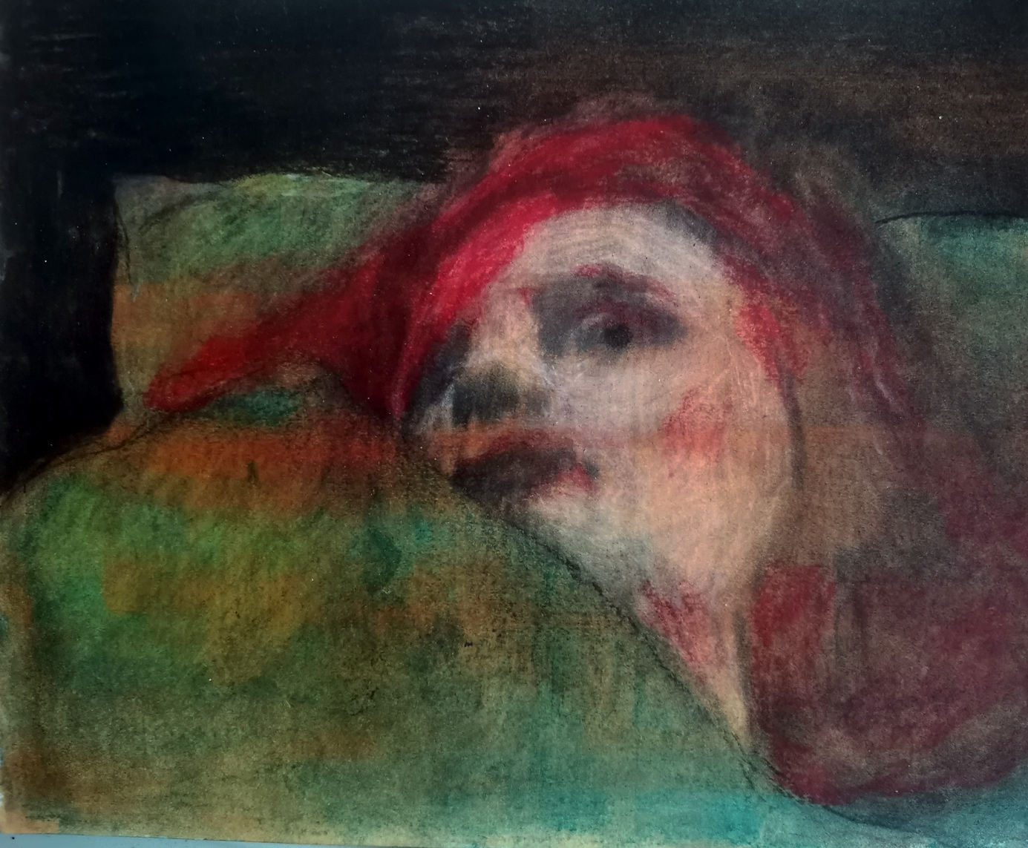

About the artist:
Siegfried Herz (1986) is a Czech artist whose work is deeply inspired by women and their inner transformations. Through his art, Herz explores how these transformations are reflected in a woman's appearance. He uses a wide range of media, including charcoal drawing, ink painting, acrylic, and coffee, which has become a signature element of his style. Beyond visual arts, Herz is also a classically trained photographer, music composer, and poet. His creative practice is influenced by an admiration for turn-of-the-20th-century authors, whose works continue to inspire him today. For Herz, inspiration is a means of forging a connection with like-minded artists whom he respects and admires.

Practical Visitor Information:
Exhibition: Siegfried Herz – The Great Noon (Velké poledne)
Venue: Trafo Gallery, Hall 14, Prague Market (Pražská tržnice), Bubenské nábřeží 306/13, Prague 7
Exhibition Dates: September 11 – October 25, 2026
Opening Hours: Tue–Fri: 3:00 PM–7:00 PM, Sat: 10:00 AM–7:00 PM, Sun: 3:00 PM–7:00 PM
Opening Reception & Catalog Launch: Thursday, September 10, 2026, at 7:00 PM
Guided Tour with Curator: Wednesday, October 7, 2026, at 6:00 PM
Admission: Free
Website: www.trafogallery.cz

Media Contact:
Blanka Čermáková - trafogallery@trafogallery.cz, 739 517 758
Alice Hromádko - alice@trafogallery.cz, 725 857 476
Šárka Samková - sarka@trafogallery.cz, 724 349 590
Markéta Jiroušková - marketa@trafogallery.cz, 776 096 825
Oldřich Linda - oldrich@trafogallery.cz, 721 834 381

We thank the partners of Trafo Gallery:
Hlavní město Praha, Skupina ČEZ, Nadace ČEZ, Hospodářské noviny, Seznam.cz, Art District 7, Hrot, Radio 1, Kudy z nudy, Wine4You a M0ST Nápoje / Beverages s.r.o.

